**CENWP-OD-B 16 October 2024**

**MEMORANDUM FOR THE RECORD**

**SUBJECT: 24BON058 MFR Maintenance to Hydraulically Lock Runner Blades on Bonneville Powerhouse One Unit 10**

On 03 January 2024 an oil sheen was observed in the Bonneville Lock & Dam Powerhouse One (PH1) tailrace in the vicinity of Unit 10 (U10). U10 was forced out of service for inspection and investigation to determine the cause of the oil leak. During the investigation process, the unit’s blade seal followers were found with significant amount of wear, indicating a possible source of oil leakage. In early September 2024 following successful blade seal replacement, an oil leak was discovered between the shaft and hub during pressure testing. This leak was originally identified upon taking the unit out of service in January 2024 but could not be replicated until September. The cause of this leak is suspected to be a failed O-ring between the shaft and hub, but this area cannot be accessed without fully unstacking the unit.

The USACE Hydroelectric Design Center (HDC) provided Bonneville Project staff with several proposed fixed blade options. After much deliberation and coordination with USACE and BPA, fixing the runner blades via digital governor block has been identified as the most feasible interim option to return U10 to service. This option is considered a short-term solution (about 5 years) until a more permanent resolution is developed and funding sources can be established, while providing Bonneville Project time to evaluate the extent of this failure mode in other PH1 units. Currently, the long-term goal is to return U10 to full Kaplan operation ability, but BPA is actively evaluating how many PH1 units can feasibly run as fixed blade in the interim.

Using data from past Turbine Survival Program (TSP) research, the preferred fixed blade angle for U10 that has been selected is 25.5o. **Figure 1** illustrates the results from the TSP Phase II research for Bonneville PH1 minimum gap runner (MGR) units. These investigations consider results based on physical injury and mortality, best geometric alignment turbine (wicket gates, stay vanes, and runner blades), barometric pressure, turbulence, and draft tube egress conditions. TSP Phase II determined the target operating range for best fish passage survival occurs when BON PH1 Units are operated with turbine unit flows between 8.5 and 11.5 kcfs. 10 kcfs was selected as a “sweet spot” to target via fixed blade configuration. As seen in **Figure 2**, a 25.5˚ fixed blade angle will result in constant turbine unit flows between about 9.5 and 10.3 kcfs.

The 25.5˚ fixed blade angle will also result in operational constraints. The estimated power impacts will range from 22 MW at 30 ft head to about 55.5 MW at 70 ft head. It is also projected that there will be about 5 MW of range at each head.

Notably, U10 will be operating above the upper 1% operating range during low head operations below about 47 ft head. However, the unit will operate below the Best Operating Point (BOP) during all head conditions. This operation falls under acceptable Fish Passage Plan operations of PH1 units:

***2024 FPP BON Section 4.2****.* ***Turbine Unit Operating Range:***

***Section 4.2.1. In-Season: April 10 – August 31 (Spring/Summer Spill for Juvenile Fish Passage)***

***4.2.1.1.******PH1:*** *Units 1-10 will be operating between the 1% lower limit and the Best Operating Point (BOP), except under limited conditions and durations when PH1 units may be operated above BOP for the use of reserves or for TDG management during high flows.*

***Section 4.2.2. Off Season: September 1 – April 9.*** *While not required to do so in the off-season, turbines will normally run within the 1% range since it is the optimum point for maximizing energy output of a given unit of water over time. Operating outside the 1% range is allowed if needed for power generation or other needs.*

**Figure 3** displays historic PH1 unit run hours across gross head elevations at Bonneville from 2001 to 2021. PH1 Units are not often operated below 47 ft head conditions, meaning time spent operating U10 between the upper 1% and BOP will be limited. When U10 is operated above about 47 ft head, the unit will be operating in the upper end of the 1% operating range.

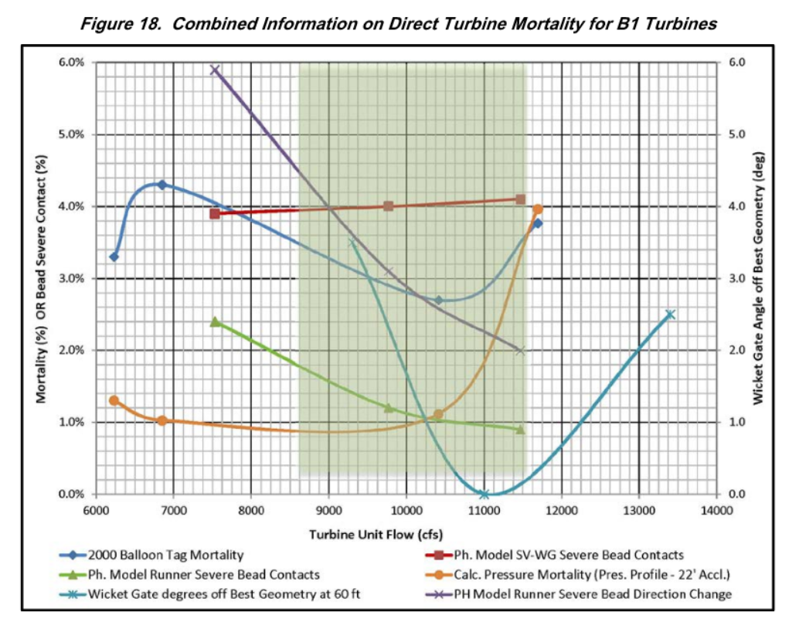

**Figure 1.** *Figure 18* from Turbine Survival Program Phase II Report showing combined information on direct turbine mortality for B1 turbines.

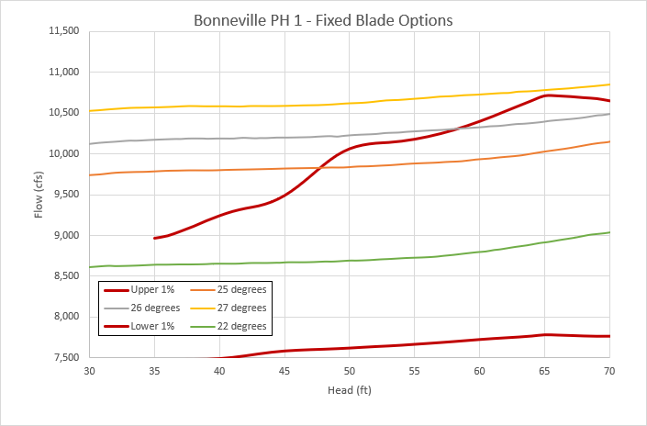

**Figure 2.** Anticipated flow ranges for four possible blade angles and 1% operating range for B1 Units found in the 2024 FPP.

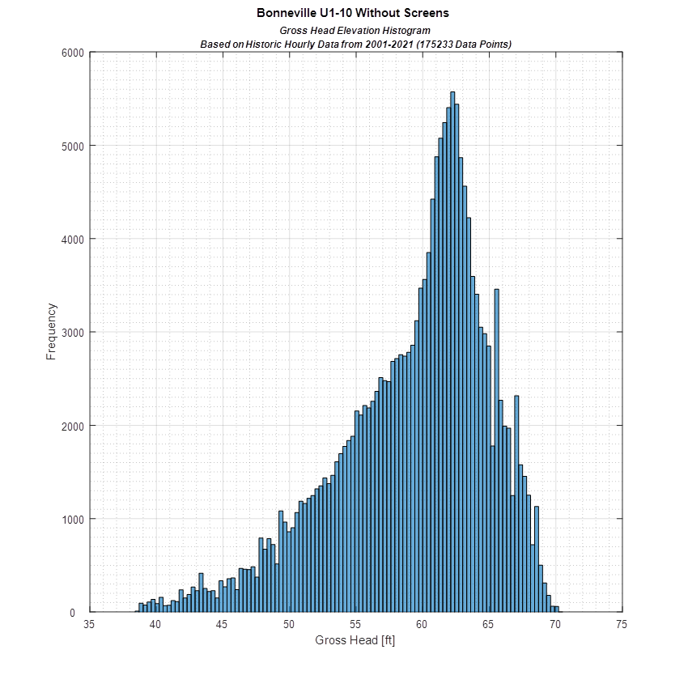

**Figure 3.** Histogram of hourly B1 unit operation across possible gross head elevations typical for Bonneville Lock & Dam.

Please email or call with any questions or concerns.

Sincerely,

Jeanette Flemmer

Chief of Fisheries

Bonneville Lock & Dam

[Jeanette.C.Wendler@usace.army.mil](mailto:Jeanette.C.Wendler@usace.army.mil)

541-374-3878